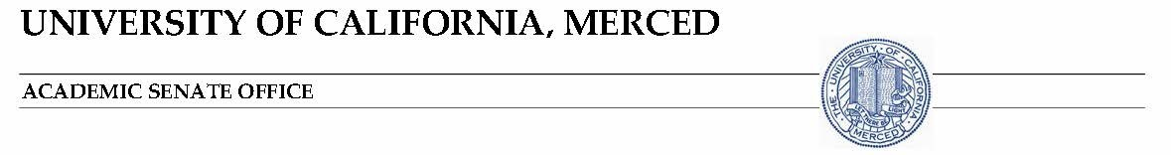

February 5, 2018

Senate Award for Excellence in Faculty Mentorship

This Senate Award is intended to encourage and recognize individual excellence in faculty mentorship. Any Senate faculty member (ladder-rank faculty and L(P)SOE) is eligible to receive this award. A list of previous recipients is provided on page 2 and available at http://senate.ucmerced.edu/senate_awards

Criteria for Award

The qualities that distinguish excellent faculty mentorship are highly variable across disciplines. In general, excellent faculty mentorship can be defined by the following traits:
- Successful mentoring of individual faculty and Unit 18 lecturers as shown by the mentees' record of success.
- Creating a positive environment where faculty can flourish.

Nomination Process

Nominations for the Senate Award for Excellence in Faculty Mentorship will be accepted from Senate faculty members and Unit 18 lecturers. Nominations will also be accepted from faculty with administrative appointments, including deans.

The nomination should discuss how the faculty nominee meets the criteria listed above. Nominations should be submitted electronically to the Office of the Academic Senate (senateoffice@ucmerced.edu) no later than 5:00 pm on March 9, 2018.

Nominations packets should include the following:

- A nomination form (appended).
- A nomination letter (maximum of two pages) that highlights the outstanding contributions of the nominee to UCM in faculty mentorship. This letter should be written by a UCM faculty member who is familiar with the nominee's accomplishments in these areas. Faculty with administrative appointments (e.g., deans) may serve as nominators.
- A current curriculum vitae of no more than two pages, with the information focusing on evidence to support the nomination.
- In addition to the nomination letter, two supporting letters (maximum two pages) specifically solicited for this nomination. These letters must be from current or former UCM faculty members or Unit 18 lecturers who are in a position to comment on how the nominee has excelled in mentoring at UCM including work within professional societies and the community.

Selection Process

The Committee on Faculty Welfare and Academic Freedom (FWAF) will form an ad hoc committee from its membership to serve as the FWAF Awards Committee with a minimum of three faculty members.

Based on the initial letters of nomination, the FWAF Awards Committee will select a slate of finalists from the nominee pool. The FWAF Awards Committee reserves the right to not give an award if there is an insufficient number of nominees, or if nominees do not meet the above criteria for the award.
Supporting materials for the finalists may be solicited. All materials and notes will be held in confidence by the FWAF Awards Committee.

The FWAF Awards committee will review nominees and select a recipient based on majority vote. The FWAF Awards Committee will complete its selection process and inform the Office of the Academic Senate (senateoffice@ucmerced.edu) of the results. On the recommendation of the Awards committee, any finalist may be nominated for the award the following year.

The announcement of the recipient will be made on April 16, 2018 during the UC Merced Meeting of the Division.

Past Recipients

2016-2017 – Miguel Carreira-Perpiñán

2015-2016 – Teenie Matlock

2014-2015 – Jennifer Manilay

EXCELLENCE IN FACULTY MENTORSHIP AWARD

Nominee’s First Name: ________________________________________________
Nominee’s Last Name: ________________________________________________
Nominee’s Position Title: ______________________________________________
Nominee’s Email Address: _____________________________________________
Nominee’s Bylaw Unit: ________________________________________________

Nominator’s Name: ___________________________________________________
Nominator’s Title: ____________________________________________________
Nominator’s Email Address: ____________________________________________
Nominator’s Phone Number: ____________________________________________

Please submit this form electronically as part of the nomination packet to
senateoffice@ucmerced.edu
By
5:00pm, Friday, March 9, 2018

